Niagara Catholic District School Board

St. Patrick Catholic School Council
By-Laws 2019-2020



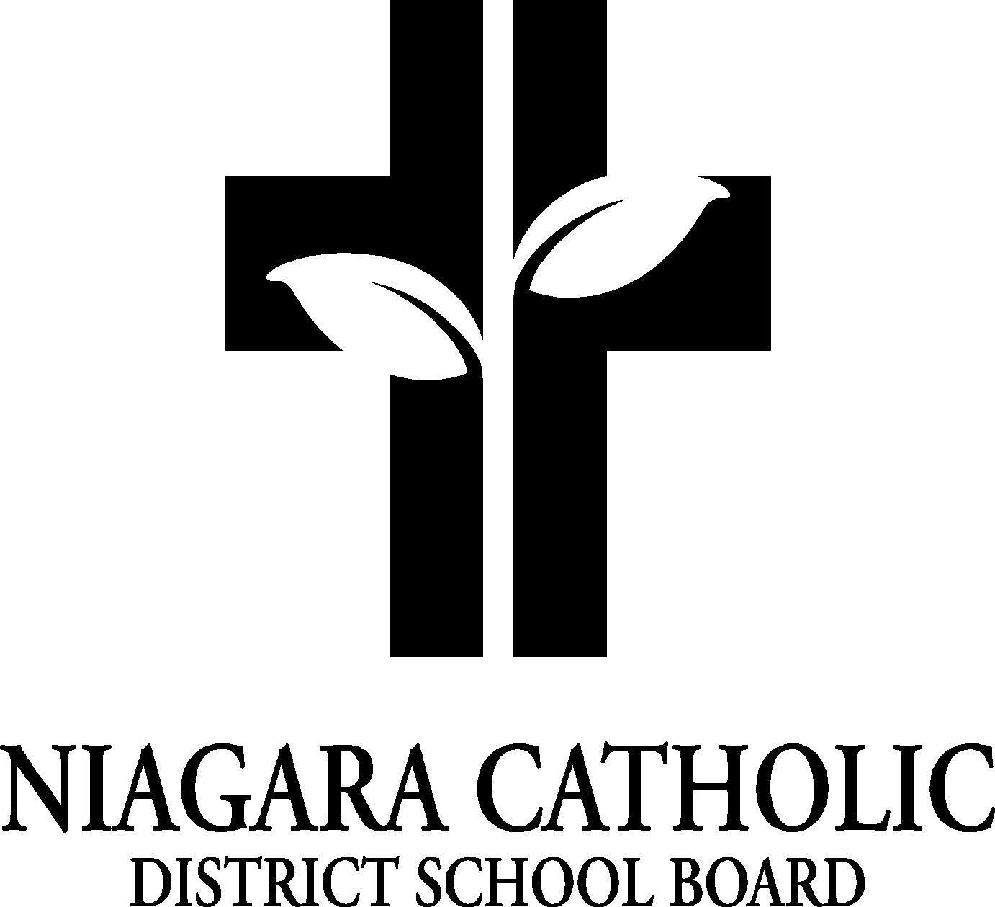
Everything that follows in these Bylaws for the St. Patrick Catholic School Council (St. Patrick Catholic School Council) must be in keeping with Ministry Regulation 612; and Board Policy (800.1).

1 Name of Council (see Board Guideline section 2)
The name of this advisory body is St. Patrick Catholic School Council.

2 Mandate of Council (see Regulation 612, section 2.1 & 2.2; and Board Guideline sections 2)
The mandate of Council is to provide advice to the Principal and to the Board, as requested, to improve pupil achievement and enhance accountability.

3 Membership (see Board Guideline section 3)
Membership of St. Patrick Catholic School Council consists of:
- A majority of Parents / Guardians (to a total of 6 members)
Custodial parents/guardians of the students enrolled in the school (elected by parents and guardians) must reside within the boundaries of the school or have Board permission to attend the school.

A person is not qualified to be a parent member of the Catholic School Council if,

i) he/she is employed at the school;
or
ii) he/she is employed elsewhere by the Board and fails to take reasonable steps to inform voters of that employment.

- Principal / (Vice Principal)
- Staff representation (academic & support staff)
- Parish representation
- Community representation (as determined by Cardinal Newman Catholic School Council)
- Student (as applicable)
- Special needs advocate (as applicable)

4 Elections & Term of Office (see Regulation 612, Board Guideline section 4, School Councils - A Guide For Members page 7.2)
1. Elections will be held within the first 30 calendar days of the start of each school
year.

2. The elections will be organized by the Principal and any outgoing council members to: review and finalize nominations, confirm names on ballots, run the election, and communicate results.

3. St. Patrick Catholic School Council will have a maximum of 12 parent/guardian members. Parents/guardians shall form the majority of the council.

4. The term of office for St. Patrick Catholic School Council members is one year. Regulations do not restrict the number of times that a member can be re-elected.

5. Names of council members will be published to the school community by the principal no later than 30 days following the election.

6. Names and addresses of elected members of the council shall be forwarded to the Director within 30 days of the election.

7. Members resigning prior to the completion of their term of office shall submit in writing a letter of resignation to the Secretary of the St. Patrick Catholic School Council.

5 Roles & Responsibilities of Catholic School Council Members
(see Ministry Regulation 612 sec 23, Board Guideline Section 5)
1. Council Chair / Co-Chair (voting members)
- Set St. Patrick Catholic School Council meeting dates & times with the Principal.
- Plan the St. Patrick Catholic School Council meeting agenda with the Principal.
- Chair the meetings.
- Ensure minutes of the meetings are recorded and maintained and submitted to the Principal for review.
- Submit St. Patrick Catholic School Council information to the Principal to be included in the existing school communications (e.g. newsletters, posters, web-site).

2. ALL elected St. Patrick Catholic School Council (voting members) shall:
- Participate in meetings.
- In keeping with the mandate of Cardinal Newman Catholic School Council (as stated in Regulation 612),
i) Parent/guardian members shall consult with parents of pupils & members of the community about matters under consideration by the St. Patrick Catholic School Council.
ii) Staff members shall consult with other staff about matters under consideration and report back to St. Patrick Catholic School Council.
- Participate in information and training sessions.
- Observe the St. Patrick Catholic School Council’s code of ethics and by-laws.
- Maintain a school-wide focus on all issues.
- Promote the best interests of the Catholic school community.
- Respond to requests from the Board.

3. School Principal (non-voting member)
- Set the St. Patrick Catholic School Council meeting dates & times with the Chair.
- Set the St. Patrick Catholic School Council meeting agenda with the Chair.
- Facilitate the operation of the St. Patrick Catholic School Council.
- Shall attend every meeting of St. Patrick Catholic School Council.
- Seek St. Patrick Catholic School Council input in areas for which it is assigned advisory responsibility.
- Act as a resource on laws, regulations, Board policies.
- Communicate with the Chair of the St. Patrick Catholic School Council.
- Act as the secretary/treasurer of the St. Patrick Catholic School Council.
- Ensure that the minutes of the meetings and financial statements are kept in the school and available to stakeholders.
- Approve / publish St. Patrick Catholic School Council information submitted by the Chair for existing school communications.
6 Meeting Procedures
(see Regulation 612, Board Guideline section 6, School Councils: A Guide for Members page 8.8)
1. Meetings will open with a prayer.

2. All meetings shall be held at the school and are open to ALL members of the school community.

3. Meetings will commence on time and not last more than two hours, unless the council agrees to a longer meeting.

4. Council meetings shall not proceed unless there is a quorum and Principal is in
attendance. A quorum is 50% + 1 of members, however the majority of members
present must be parents/guardians. 201-2018 will require 7 parent representatives.

5. Substitutes or proxies will NOT be permitted.

6. The Principal will make every effort to distribute the agenda to members in advance.

7. St. Patrick Catholic School Council may establish committees to carry out specific functions and to seek greater community participation.

8. St. Patrick Catholic School Council shall strive to use consensus as the usual method for developing recommendations to the Principal.

7 Vacancies
(see Board guideline sec. 7)
1. The expectation of the St. Patrick Catholic School Council is that members attend council meetings regularly. The Chair, Co-chair and Principal shall address incidents of member's irregular attendance to determine the member’s intent or ability to
continue serving on St. Patrick Catholic School Council.

2. There will be no discretionary removal of a duly elected or appointed St. Patrick Catholic School Council member before the end of his or her term.

3. If a vacancy of a parent member occurs and this vacancy unbalances the simple majority of parents, the position will be filled by a parent volunteer approved by the Chair and the Principal.

- If a vacancy of a community representative occurs, the council will fill the position by a community representative approved by the Chair and the Principal, or choose not to fill the position.

5. If a staff or student representative vacancy occurs, the Principal shall arrange
for a replacement, where possible.

6. Individuals filling a vacated position shall hold the position until the term for that
position expires.

7. A vacancy in the membership of St. Patrick Catholic School Council does not prevent the council from fulfilling its mandate.

8 Code of Ethics (adapted from School Council – A Guide for Members)
(see Board guide sec. 8 & MOE document School Council - A Guide For Members revised 2002, p5.5)
1. A member shall:
- Consider the best interests of all students.
- Be guided by the school’s and the board’s mission statements.
- Become familiar with and act according to school & board guidelines, and Ministry of Education regulations.
- Maintain the highest standards of integrity, recognizing and respecting the personal integrity of each member of the school community.
- Treat all other St. Patrick Catholic School Council members with respect and allow for diverse opinions to be shared, without interruption.
- Create a positive environment in which individual contributions are encouraged and valued.
- Acknowledge democratic principles and accept the consensus of the council for recommendation to the Principal.
- Respect the confidential nature of some school business, respect the limitations this places on the operation of St. Patrick Catholic School Council, and not disclose confidential information.
- Focus discussions at St. Patrick Catholic School Council meetings to those items that fall within the mandate of St. Patrick Catholic School Council.
- Use established communication channels when questions or concerns arise.
- Promote high standards of ethical practice within the school community.
- Not accept any payment for their St. Patrick Catholic School Council involvement.
- Refrain from making any negative statements about any individuals or groups.
- Declare any conflict of interest.

2. Conflict of Interest
Any time the St. Patrick Catholic School Council recommends a business transaction with the potential for monetary gain/loss for any person, agency, or company, and a member of Cardinal Newman Catholic School Council has a vested interest in any way with that particular person, agency, or company, that member shall declare a conflict of interest and shall not be present to discuss or recommend actions relating to the matter.
A conflict of interest may be actual, perceived, or potential (see School Councils – A Guide for Members page 7.12 for definitions)

9 Review of Bylaws (see Board guideline sec. 9)
1. As part of the review of their effectiveness, at the last meeting of the year the outgoing St. Patrick Catholic School Council shall formulate recommendations regarding amendments to the Cardinal Newman Catholic School Council Bylaws to forward to the incoming Council for their consideration.
2. St. Patrick Catholic School Council shall review its Bylaws annually, at their inaugural meeting, to familiarize the new Cardinal Newman Catholic School Council members with them, to ensure compliance with Ministry Regulations and Board Policies & Guidelines, and to consider the amendments recommended by the preceding St. Patrick Catholic School Council.
3. All Bylaw amendments shall be approved by a majority vote of St. Patrick Catholic School Council.

10 Delegations (see Board guideline sec. 10)
1. Individuals may approach the chair or the principal to be placed on the agenda. The Chair, in consultation with the Principal, may approve or reject such requests. This request must be made with ample time prior to the meeting to consult and prepare.

2. Delegations will be limited to ten minutes.

11 Resolution of Conflicts (see Board guideline sec. 11)

1. If, in the opinion of the Principal, after discussion with the St. Patrick Catholic School Council Chair, and after addressing the issue with St. Patrick Catholic School Council, the process and advisement of the St. Patrick Catholic School Council contravene the mandate of the Board and/or the Principal, and special interest groups seem to be controlling the agenda of St. Patrick Catholic School Council, the Principal or Chair may approach the Family of Schools Superintendent to discuss the matter.

2. The decision of the Family of Schools Superintendent may be appealed to the Director of Education.

3. The decision of the Director of Education is final.

12 Conflict Resolution Process (adapted from School Councils – A Guide for Members)

- If a member becomes disruptive during a meeting, the chair shall ask for order.

- If all efforts to restore order fail or the unbecoming behaviour continues, the chair may direct the individual council member to leave the meeting, citing reasons for the request.

- The removal of a member for one meeting does not prevent the member from participating in future meetings of St. Patrick Catholic School Council.

- The incident shall be recorded and submitted to the Superintendent of Schools by the Principal within one week of the meeting.

- It is recommended that parties involved in the conflict follow the Board’s complaint process.

- Upon removal of a member, a special meeting shall be called, the purpose of which will be to arrive at a mutually acceptable solution to the dispute.

- Such a meeting shall be a private meeting and not construed as a meeting of St. Patrick Catholic School Council.

- Any resolution reached at the meeting to resolve the conflict shall be signed and respected in full by all parties to the agreement.

13 Fundraising (see Board guideline sec. 12)

1. Any school based activities that act as fundraising shall be conducted in accordance with Board policies and guidelines.

2. Any profits realized by St. Patrick Catholic School Council activities and initiatives are deemed to be “school-generated funds” and legally belong to the board.

3. School generated funds are to be used for a purpose recommended by the Cardinal Newman Catholic School Council and approved by the Principal (and the Board, when appropriate).

4. Any assets purchased with school generated funds belong, legally, to the Board.

5. All activities promoted by St. Patrick Catholic School Council that generate a profit or loss must be included in the annual report to the Board and community, prepared by the St. Patrick Catholic School Council.

